Thermoacoustic Project WS 2024

PINN Project - EXPERIMENTS

**24-12-17_1521(checkpoints) - 2146(loss) (cluster1)**

adam_iterations = 5000

lbfgs_max_iterations = 50000

total_loss = 10*yB + 10*yC + 100*yD + yS



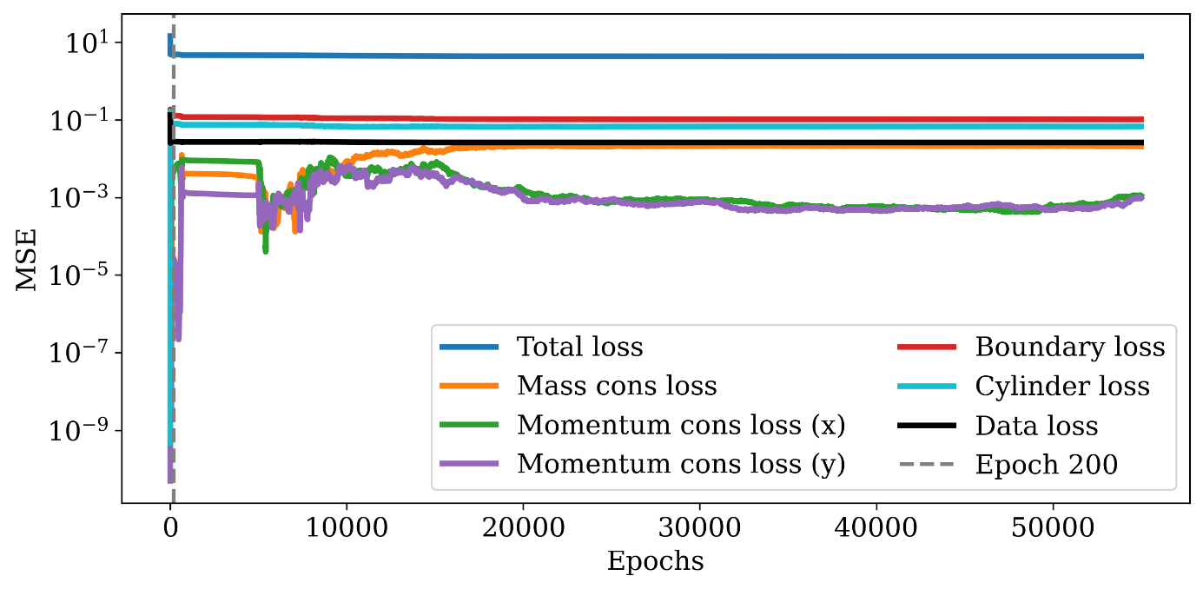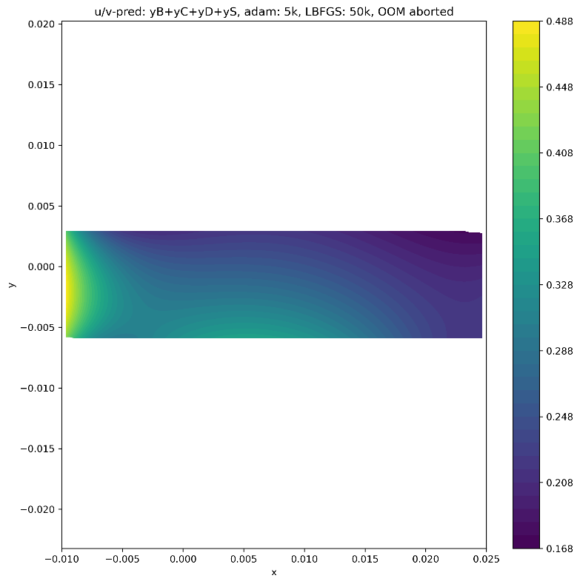

* Data_loss converged but too high
* Mass_loss rising
* Mom_losses rising to

**24-12-17_1557 – 0019 (cluster2)**

adam_iterations = 5000

lbfgs_max_iterations = 50000

total_loss = 10*yB + 10*yC + 100*yD + loss_mom



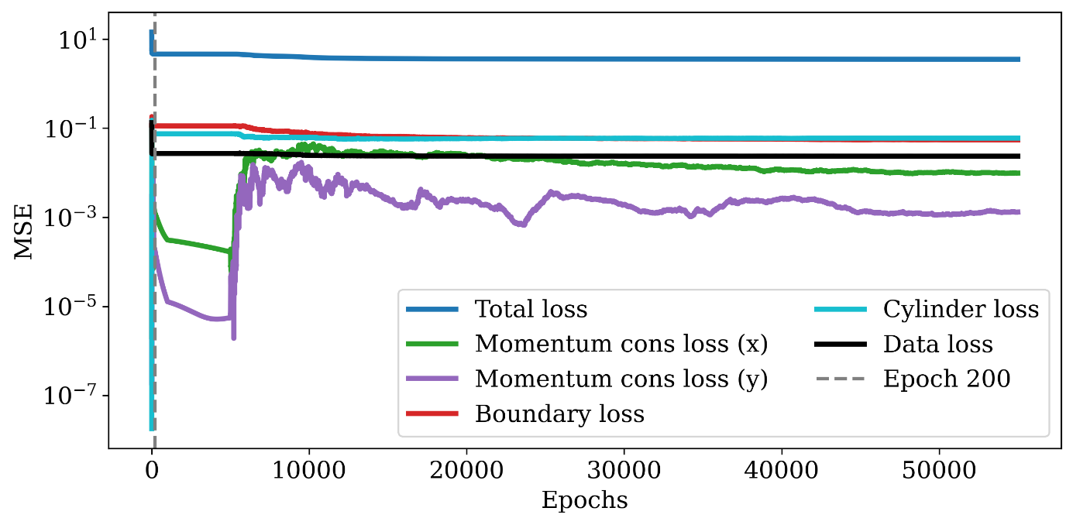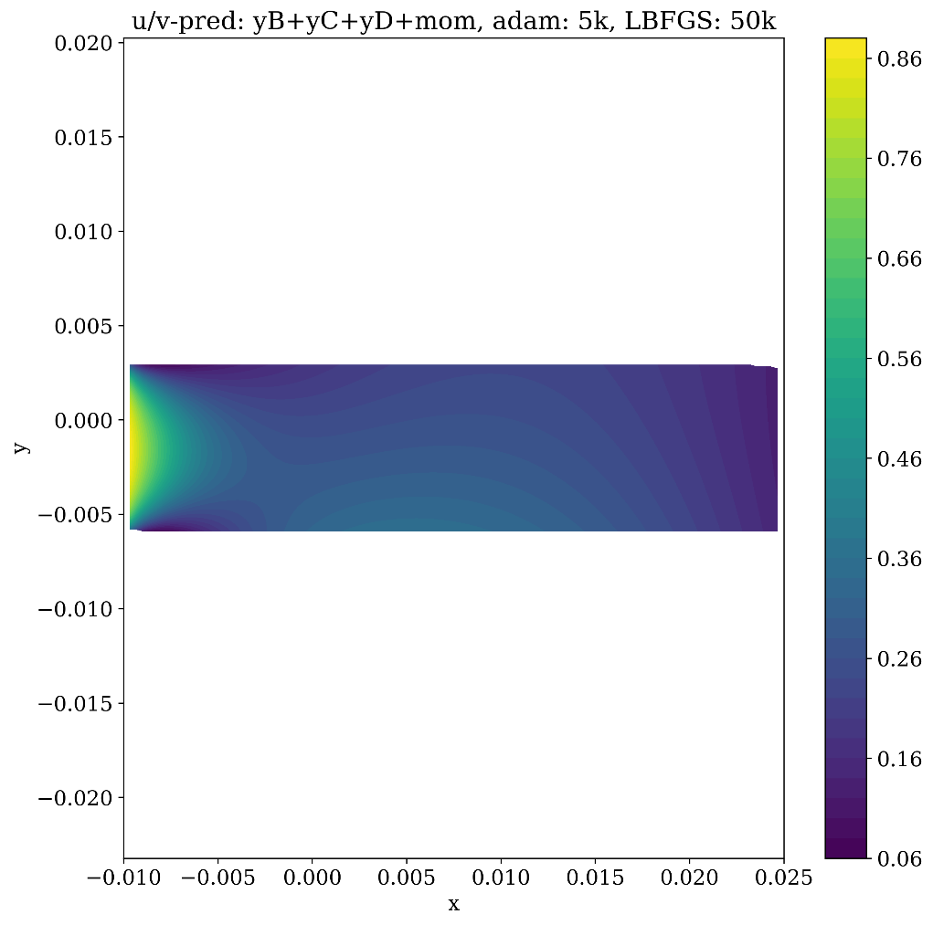

* Mom loss too high

**24-12-17_1613 (cluster3)**

adam_iterations = 5000

lbfgs_max_iterations = 50000

total_loss = 10*yB + 10*yC + 100*yD + loss_mass

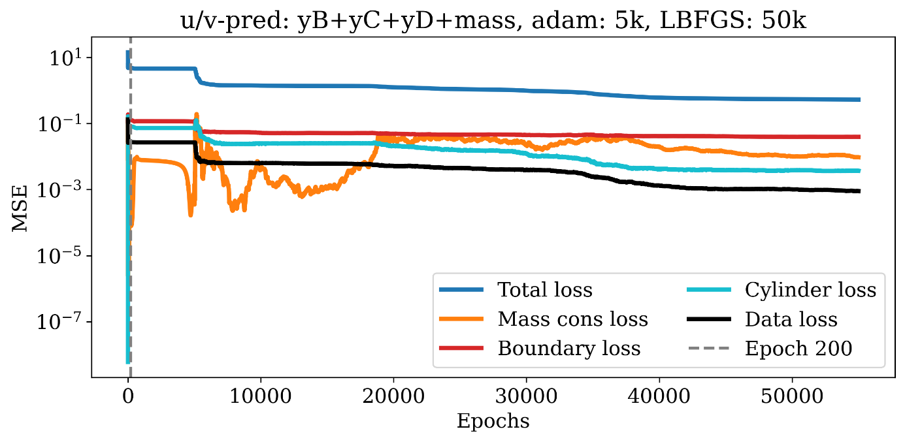

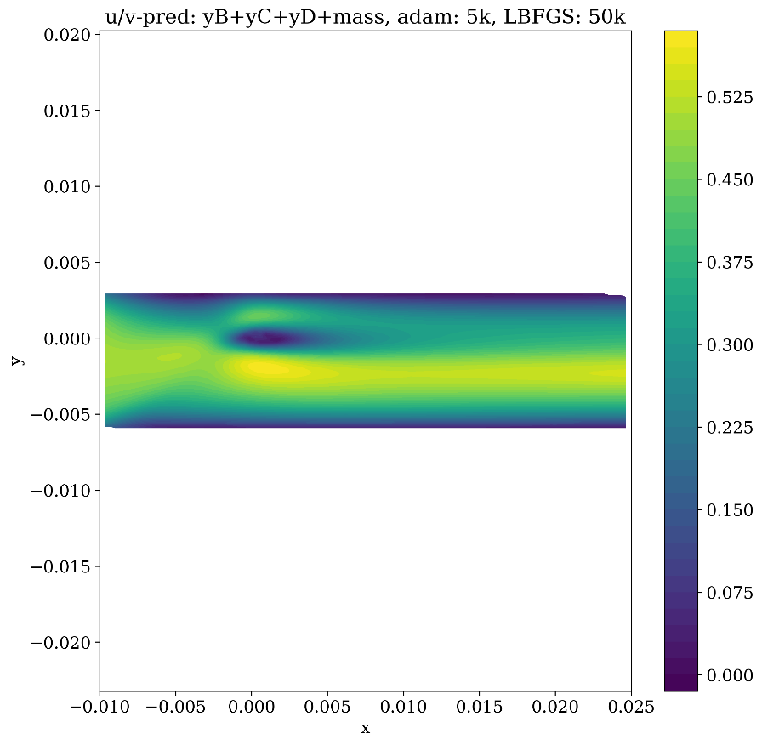

* Total loss still converging
* Best velocity profile

**24-12-17_1638 (cluster4)**

adam_iterations = 5000

lbfgs_max_iterations = 50000

total_loss = 10*yB + 10*yC + 100*yD +yS



